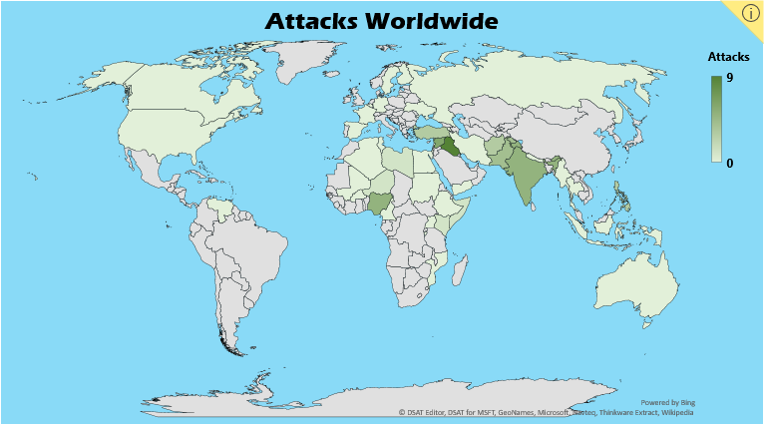

The Week in Terrorism

01/15/2018-01/21/2018

Global Total

**41 Attacks**

**159 Killed**

**337 Wounded**

See the data at http://www.risetopeace.org/rise-to-peace-3/active-intelligence-database/r2p-active-intelligence-database/

Noteworthy

ISIS carried out two large attacks. Tayaran Square in Baghdad, a popular place for day laborers to gather and look for work, was struck by two suicide bombers. In Syria, a suicide attacker drove a bomb-laden vehicle into a group of pro-Coalition fighters. ISIS is also responsible for six more small-scale attacks in Iraq. Despite recent losses of territory, this marks the second week in a row that ISIS was responsible for the largest attack.

Boko Haram carried out five attacks throughout Nigeria and Niger, including a twin suicide bombing on a market in Muna Garage that killed twelve and injured forty-eight.

Tehreek-e-Taliban Pakistan (TTP), Al-Shabaab, the New Peoples’ Army, Jaish-e-Mohammed, Bangsamoro Islamic Freedom Fighters (BIFF), and the Naxalites all committed small attacks that left injuries but no fatalities. Countries affected include Pakistan, Somalia, India, the Philippines, and Kenya.

From last week, total attacks increased by 37%, fatalities increased by 148%, and injuries increased by 221%.